**Milestone 4 Resubmission**

Changes added to Milestone 4 in response to the Comments for system feedback by addressing the problems identified by users in the user testing process

* Fix the filter by attribute function by rephrasing the description
* Fix the submit a review function by adding a confirmation message pop-up
* Fix the registration message
* Fix the registration function by adding a confirmation message pop-up

Because current WebStac system (and the school) allows the registration of the classes of conflicting schedules, the new system does not prohibit the registration of conflicting classes.

**Milestone 4**

For our final milestone we were to complete 2 rounds of user testing with our digital prototype and 1 non-user based evaluation. We conducted the user interviews in a very similar manner to how we conducted the interviews with our paper prototype. We presented users with tasks, listed below, and had them complete the tasks to observe any confusion with our prototype or any functionality issues that users came across.

We chose to do one round of user interviews, followed by a non-user evaluation, followed by the final round of user interviews. We thought this was a good way to spread out the user interviews and make the final round of interviews the most worth while. For our non-user based evaluation we chose to conduct a cognitive walkthrough because we wanted to really explore the usability of our product.

**User Demographics**

* Ciel, Senior, computer science major
* Sylvia, Junior, International studies major
* Josh, Sophomore, undeclared but possibly Business Administration and Math double major
* Sean, psychology Senior
* Ted, Junior Biology
* Taylor, Graduate Computer Science
* Sojin, Master, Electrical Engineering

Summary: 1 sophomore, 2 juniors, 2 seniors, and 2 graduate students. 3 Engineering students, 1 undecided, 3 arts & sciences.

We used the same approach to finding users that we have done in previous milestones, going to the DUC and asking students that appear to not be working on homework or working in a group if they have a few minutes to conduct an interview. We have found in the past that this results in a pretty diverse group of students, specially diverse in department and school. This time we noticed that we happened to interview more upper level students then freshman and sophomores. This might add a little bias to how user searched for a course, but because this system is new to every user we tested with we don’t feel like it is a large issue.

**Tasks for Round One**

The following tasks were presented to users and testers to evaluate our prototype in round one.

1. You are a Biology major at WashU with the username "betty". You are currently enrolled in BIO 2961 - Collaborative Phage Bioinformatics. You are currently getting a "D" in the course and are not enjoying it very much, so you wish to drop. Before you drop however, you want to write a review for the course to let future students know how you feel.

2. You are the same user "betty" as before. You now need another class to enroll in after dropping BIO 2961, and you've heard your friends talk about a BIO 3041 class that they loved and you want to find more details about it to decide whether or not to register for it.

3. You are a Law student by the username "seth". You already have a registration worksheet ready and waiting that you have prepared, but you need to complete the registration process quickly to make sure you aren't waitlisted.

4. You are a CS student named "dave". It is still registration period and you have signed up for a few courses, but feel like you need to take another. You need one more CS elective, and you need to find something that fits into your schedule.

5. You are a CS student named “sal”. You have completed most of your CS requirements, but not your A or S requirement. You want to find something you are interested in that will count towards your A requirements

6. You are a BIO student named “frank”. You started getting into music this past summer while at your internship. You have the space in your schedule and want to continue learning more about music this semester, and you have heard that jazz and K-Pop are really cool to study at WashU.

**Summary of Round One:**

Round one was our first round of user interviews after creating the digital prototype. During this round we interviewed 3 WashU students. One computer science senior, a internationals studies junior, and an undeclared sophomore. While conducting this round of interviews we came across a lot of stylistic issues. A lot of our users were focused on things regarding style of our site. Another theme for issues during this round was how to navigate around this site. Users expressed a disappointment in not having a back button, or a way to return to the search. They also seemed upset that there was no way to sign out. Both of these were things that we hadn’t really included in our system because we didn’t think that they were necessarily a part of the tasks, but we did decide to add them because they are things that help users accomplish the tasks. We also fixed other logistic issues found during this round to make the next two round of testing more smooth.

**First Round Interview Transcripts:**

1. **Ciel, Senior, computer science major**

Q (interviewer): Hi Ciel, thanks for helping me with testing my HCI class project. So what we did is basically redesigning the registration part of Webstac.

C: Okay sounds cool.

Q: so here is the redesigned registration portal (showing her the login page). You can start now (giving her tasks that were printed on paper).

C: okay I’ll start with login...so I’m betty with a bio major. BTW I really don’t like the background color of the login page.

Q: sorry about that!

C: so now I want to find bio 2961 and write a review. Oh here is 2961 (pointing at the calendar). That’s handy. (click on Bio 2961)

C: (after a 0.25 second pause click on “write a review” button) I’m gonna rate it a 2 and say it’s a horrible class because exams are way too hard.

Q: Sure.

C: submit (hit “submit button)...now i’m going to drop the class (hit “drop course” button). Hmmm why do you still want the course in your wishlist? Well I guess it’s fine there could be occasions that people are unsure.

C: Now what’s next?

Q: Look for an alternative for BIO 2961.

C: alright I can just go to registration then (click “registration” button and page directed to Registration). Wait this is just for registering? Oh I see. I should go to search (click on search button).

C: now I need another bio class (choose “Art Sci” and “Bio” from the two dropdown menus then click on “search” button).

C: (scrolling down the page) here is bio 3041! (click on course name). Hmmmm...the description sounds alright. And with a 4-star review. I think I can register for it (click “Add to Wishlist” button). I guess there is no direct registering right?

C: (click “Register” button) now I’m going to hit “Enroll.” (click “enroll” button)

C: I’m going to double check (click “Home” button). Wait why is it search page? Oh I see (click “my account” page and page redirects). Yay now I have BIO 3041 registered.

Q: now you can move on to task 3.

C: alright. So now I’m seth and i just need to register as soon as possible. (logged in as seth). Well now I already know the procedures (click “Registration” button then click “enroll” button after page redirected).

C: cool I think I can go to task 4 now.

Q: yup.

C: (closed browser window and start over again) Now I’m Dave (logged in as Dave). Fits in schedule...let me check my schedule first.

*Ciel scans through the calendar

C: so I can take MWF afternoon classes or TR morning classes. Now I’m going to search (click “Search” button).

*Ciel chose “Engineering” and “CSE” from the two drop down menus and hit “search” button.

C: Now how can I check for prereqs?

*Ciel scrolled down the page a little bit and looked around until she accidentally caught the sight of the filters

C: Oh wait there is filters? Yay I like filters (click on “Fulfill Requirement” button).

C: let me check...MWF afternoon or TR morning. CSE 231 on TR morning sounds good (click on course title and page redirects).

*Ciel scanned through course description then scrolled down to check reviews.

C: 2-star?! Nah I’m not going to take this class. I’ll find another class.

*Ciel clearly pauses for a second and then uses the browser’s back button.

C: I think there should a back button on course detail page...anyway, need to find another class. What about CSE 204? (click on course title)

C: (scanned through course description then scrolled down to check reviews) wow a super easy class! Alright I’m in (click “add to wishlist” button).

*Ciel clicks “registration” button then clicks “enroll” button after page redirects. After that, she clicks “Your Account” to double check registration status and then closes browser.

Q: now task 5.

C: Yes! (log in as sal) now what? Attribute search? Gees you know how much I hate those A/M classes…(click “search” button while talking)

*Ciel chooses “Engineering” and “CSE” from the two dropdown menus then click on “search” button

C: (look around the filter bar) wait, there is no filter by attribute option? Is it really necessary to have this task if I just have to look for every class and check the attribute?

Q: you’re right. That’s a good point.

C: right? Well I already know CSE 260 is a M-class so I’ll just go with that (click on course name).

*Ciel clicks “add to wishlist” button and then “Register” button. She then clicks “Enroll” button.

Q: Finally the last task!

C: woo-hoo! (log in as frank) hmmmm jazz or k-pop class (clicks “search” button).

C: (type in “k-pop” in the text box then click “search” button) I’m going to search k-pop first because I like kpop. Wow do we really have a k-pop class at WashU?

Q: yes we do!

C: That’s really cool (click course title)!

*Ciel looks through course description and reviews and comments on that it is a very cool class.

C: alright I’m taking this. Forget about jazz (click “add to wishlist” button then “register” button).

*Ciel finally clicks “enroll” button.

C: I guess I’m done?

Q: Yes! Thank you so much for your time Ciel!

**2. Sylvia, Junior, International studies major**

Q (interviewer): Hi Sylvia, thanks for helping me with testing my HCI class project. So what we did is basically redesigning the registration part of Webstac.

S: Uh-huh.

Q: so here is the redesigned registration portal (showing her the login page). You can start now (giving her tasks that were printed on paper).

S: Thanks! So I just pretend I’m the virtual persona and do the tasks?

Q: Yes!

S: Okie dokie. Haha I’m Betty now.

Q: lol

S: (log in as Betty) wow this page is refreshing.

*Sylvia clicks a couple different tabs and then return to calendar view. She randomly clicks on a class in the calendar and the page was redirected. So she returns to the last page and licks on BIO 2961.

S: This is really cool that you can see reviews on course page. But I feel professors may not be so happy about this…

Q: Yeah we were mainly considering for students haha.

S: Anyway. I’m gonna write the review now (click “write a review” button).

*Sylvia chooses 1 start with grad D from the two dropdown menus and writes down some reviews. She then clicks “submit” button. Upon submission, she clicks “drop course” button.

S: done with first one! Now...I’m still Betty and need to check BIO 3041. So I would just go to search now (click “search” button). Wow I like this page!

Q: Thanks!

S: Yeah the background picture is...hmmm...refreshing. Haha (enter “3041” in the textbox. As page redirects, she clicks the course tile “BIO 3041: course name”).

S: oh ok. So I would first see if the course description sounds interesting to me. Biology is for sure nothing related to interesting to me but I guess it’s good enough for a Bio major. Usually I would go to ratemyprofessor to check reviews but since there is already a review, I’m just gonna check this one. It looks pretty good to me. I guess I can just register for it.

*Sylvia hesitated for about a second then clicks “add to wishlist” button. She then clicks the “Register” button.

S: ah it’s right here (pointing at BIO 3041 in the waitlist)!

*Sylvia clicks “enroll” button.

Q: Sow we can move on to task 3.

S: Sounds good to me! Wait, I cannot log out on this page.

Q: That’s a very good point! Thanks for pointing that out Sylvia!

S: No problem! How can I go back to the login page then?

Q: No worries. I can just show you the login page (reopen the website and show her the login page)

S: Thanks. Seth...one two three...should I just go to Registration page then? Yeah probably…(click “registration” button)

S: (clicks “enroll” button and the page refreshes) I’m done!

Q: cool!

S: Sorry...can you pull out the login page again?

Q: yeah yeah yeah no problem (showing her the login page)!

S: Thanks! Now task 4...dave…(log in as dave)

S: Okay I’ll need to check my schedule first (scanning through the calendar). I really like this weekly calendar and the academic calendar idea. It’s so much easier than googling “washu academic calendar.”

Q: I hate that too…

S: But anyway. I need a comp sci class that fits in either MWF afternoon or TR afternoon.

Q: Whatever you would like.

S: haha I would be surprised if you say I can only take MWF classes.

*Sylvia clicks “search” button. She then chooses engineering and CSE from the two dropdown menus and clicks search button.

S: quite a lot CS classes huh?

*Sylvia immediately notices the filters.

S: well I can only filter by day, not afternoon or mornings...do I just check the meeting time myself?

Q: well you’ll need to figure out yourself.

S: alright, alright. Hmmm...I know CSE 131 is the intro class so I probably cannot take it anymore. What about 204? I guess it’s a bit too early but web development sounds fun right (click on course title)?

S: okie the reviews look pretty good too (click add to wishlist).

*Sylvia then clicks “register” button and “enroll” button to register this class. She then asks for relaunching of log in page for task 5.

S: What are there A/S requirements?

Q: it’s an attribute that tells you what type this class is.

S: So I’ll see it in course description?

Q: you’ll figure it out yourself.

S: alright (log in as sal)…

S: (click on “search” button) I’ll look through all the CS courses then.

*Sylvia chooses engineering and CSE from the two dropdown menus and clicks search button. She checks a couple courses with course description and reviews and finally registers CSE 231.

S: wow it’s the last task already.

Q: yay!

S: (log in as Frank) search again with jazz huh…(click search button)

Q: You look kinda tired.

S: Yeah the tasks are a little repetitive but that’s alright...it’s the last one.

*Sylvia types in “jazz” in the textbox and clicks search button. She then clicks course title in search result page. After checking course descriptions and reviews, she clicks “add to wishlist” button. She then repeats the above procedures to search and add k-pop class.

S: (clicks register button) now register!

S: (try to only add the jazz class but pause) this is not add button. Am I supposed to add the classes one b one?

Q: I think you should be able to but we are missing that button. Thanks Sylvia!

S: yep (clicks enroll button). Now I’m done!

Q: Thank you so much Sylvia!

**3. Josh, Sophomore, undeclared**

Q (interviewer): Hi Josh, thanks for helping me with testing my HCI class project. So what we did is basically redesigning the registration part of Webstac.

J: No problem!! I’m happy to help.

Q: so here is the redesigned registration portal (showing him the login page). You can start now (giving him tasks that were printed on paper).

J: nice. This is neat.

Q: Thanks.

J: alright, Betty! (log in as Betty) nice home page! Calendar, academic calendar...nice nice!

Q: Thanks Josh!

J: Can we add items on academic calendar and export the calendar too? That’s gonna to be so cool!

Q: well...currently in progress lol.

J: haha got you! So what should I do? Write a review and drop class. I literally did the same thing last semester haha. Where is registration status? (click on registration button)

J: No this is not registration status (click home button). What is this? Ah search page! So... I should actually be going to My Account page (click “my account” button). And I guess these are actual links (click course name on calendar).

J: Ha! I got this. (click on “write a review” button, enter review context and choose rating and score; hit submit button then hit “drop course” button).

J: this is straightforward. I got this.

Q: great!

J: now add another course. Going back to search (click search button)

*Josh enters 3041 in the textbox and hits search button.

J: honestly the title didn’t stand out.

Q: the title?

J: search for class! The title! You see?

Q: ah I see what you mean here.

J: maybe using another color would be better?

Q: I’ll take that advice. Thanks Josh!

J: No prob. (click course title in search result page) already. Now register!

*Josh pauses for a second and clicks “add to wishlist” button.

J: so still has to add course to worksheet then register.

Q: well…

J: nah it’s alright. (click registration button then enroll button)

J: I think I already know this system.

Q: I’m glad that you do.

J: third task? (look around the page) how can I log out?

Q: sorry we are missing the sign out button. Just ignore it and close the browser. Then relaunch it.

J: Got it. (relaunch and log in as seth) now go straight to register (click register button then enroll button)!

J: that was a super easy task.

Q: haha.

J: (relaunch and log in as dave) looking for cs elective? I want a CS elective too.

*Josh clicks search button then chooses Engineering and CSE from the two dropdown menus and clicks search button.

J: are these real courses?

Q: Yup! I scraped from webstac.

J: crazy. Did you use a program to do that? Alright I’ll go back to the task. No...I forgot to check my schedule first.

*Josh clicks “my account” button then looks for schedule. He then searches for CS courses.

J: CSE 131. The time works. (clicks course title and looks through description and review) looks like a mandatory class. I should probably take it (click add to wishlist button then enroll button).

J: Task 5 already! I think I like the new system now.

Q: Thanks!

J: (relaunch and sign in as sal) what for? What is A/S requirement?

Q: well it’s an attribute that tells you what type this class is.

J: sounds fun haha. (click search button and search for CS classes) what are the A/M class?

Q: you’ll need to figure them yourself.

J: a-l-r-i-g-h-t. CS 132? (click course title and read through description) no it’s not…

*Josh checks a couple courses with course description and reviews and finally registers CSE 217

J: final task! Frank!

Q: yay!

J: (relaunch and log in as frank) to be honest I’ve never taken any music class at WashU. Maybe I should consider it…

*Josh clicks search button and enters jazz in the textbox. He then clicks search button.

J: history of jazz (click course title). But the description is way too short.

Q: I scraped from webstac…

J: no worries. The review is not that great either. I should check k-pop instead.

*Josh clicks home button and enters k-pop in the text box. He then clicks search button.

J: (click course title and read through course description and review) it does look like a very fun class!

*Josh clicks add to wishlist button then register button. He then clicks enroll button.

J: here it is. Finished!

Q: Thank you so much for your time Josh!

**First Round Interview Notes:**

1. Ciel, Senior, computer science major
2. Suggest change of background color at first sight
3. Login, search, click and choose one course all went well
4. Suggest changing the button alignment in course detail page (specifically moving the “write a review” button to the bottom of the page) and removing the grey “1 review” notification under the “write a review” button
5. Suggest removing the rating number of a course and just keep the dots that represent the rating
6. Was confused when there was no back button in the course detail page
7. Couldn’t find search by attribute filter (task 5)
8. No problem with home page or registration (although suggested that “Home” should be “My Account”)
9. Thought registration should be centered (current it’s in the left of the page)
10. Sylvia, Junior, International studies major
11. Login, search, click and choose one course all went well
12. Was confused that Home and My Account were not the same page but accepted the idea soon after she got used to the system
13. Didn’t really like the search result page (thought the content should be centered and not take up entire space→ should have margins)
14. On Academic calendar, last day of class was listed as Saturday (should be Friday)
15. Thought graduation requirements should list the classes that fulfilled the requirements
16. Couldn’t find search by attribute filter (task 5)
17. Thought the process of dropping course was not intuitive enough (course should be able to be dropped directly in My Account page)
18. Tried to click on a course in worksheet/wishlist, didn’t work
19. Was confused by worksheet and wishlist→ name should be unified
20. When registering for class, it didn’t show conflict of schedule
21. Tried to register only one class in the worksheet→ could not
22. Josh, Sophomore, undeclared but possibly Business Administration and Math double major
23. Login, search, click and choose one course all went well
24. Noticed that there was no “sign out” button
25. Suggest to add your name after “Welcome” on my account page Tried to search by professor name--didn’t work
26. Noticed that Design & Visual Arts school had no class (neither did school of Medicine)
27. Couldn’t find search by attribute filter (task 5)
28. Suggest that in search page, the title “search for classes!” doesn’t have enough contrast with the background picture
29. “Can we add items on academic calendar and export the calendar too?”

**Changes made after Interview 1**

1. Added search by professor functionality
2. Added sign out button
3. Added a back button from course listing
4. Allow for dropping course from account page
5. Change date for end of classes

After a discussion of what we thought was important feedback we decided to add the above changes to help users. We added the ability to enter a professor's name in the search field to get classes they were teaching. We also added a sign out button so that users could switch between tasks/users. We also added a back button; this had the same functionality as the back button in a web browser, but we thought it might help users that would want to return to search results. We also changed the way users would drop a course. We added it as a pop up window so that there would be no leaving your schedule, and less pages seems to be less confusing. Finally we changed the date for end of classes, because while small was a silly mistake to have classes ending on Saturday.

**Round 2 using Cognitive Walkthrough**

After making the changes above from the first round of interviews we started our cognitive walkthrough. One reason we chose this over GOMS or heuristic evaluation was that we really wanted to put an emphasis on the different tasks that users would be completing. We felt that sometimes when you design a product sometimes you get boxed into one way of solving each task, and by laying out these rules and structures that we have created we might see where we created limited interactions. We had created a few tasks that would require users to not enter anything in the search field, and by doing this cognitive walkthrough we realized that isn’t really an intuitive step. When creating the system it makes sense to cut corners and then filter your results, but to a new user that might not be obvious. We also felt that because we use the same forms to complete many different types of tasks that remaining focused on tasks would give us better results.

Below are the notes that we took during the cognitive walkthrough. You will notice that many of them start with the same login process for the first 5-6 steps. This is mostly due to how we “faked” our backend. Each task had a different user so that we could set up requirements and schedules for each student.

1. You are a Biology major at WashU with the username "betty". You are currently enrolled in BIO 2961 - Collaborative Phage Bioinformatics. You are currently getting a "D" in the course and are not enjoying it very much, so you wish to drop. Before you drop however, you want to write a review for the course to let future students know how you feel.

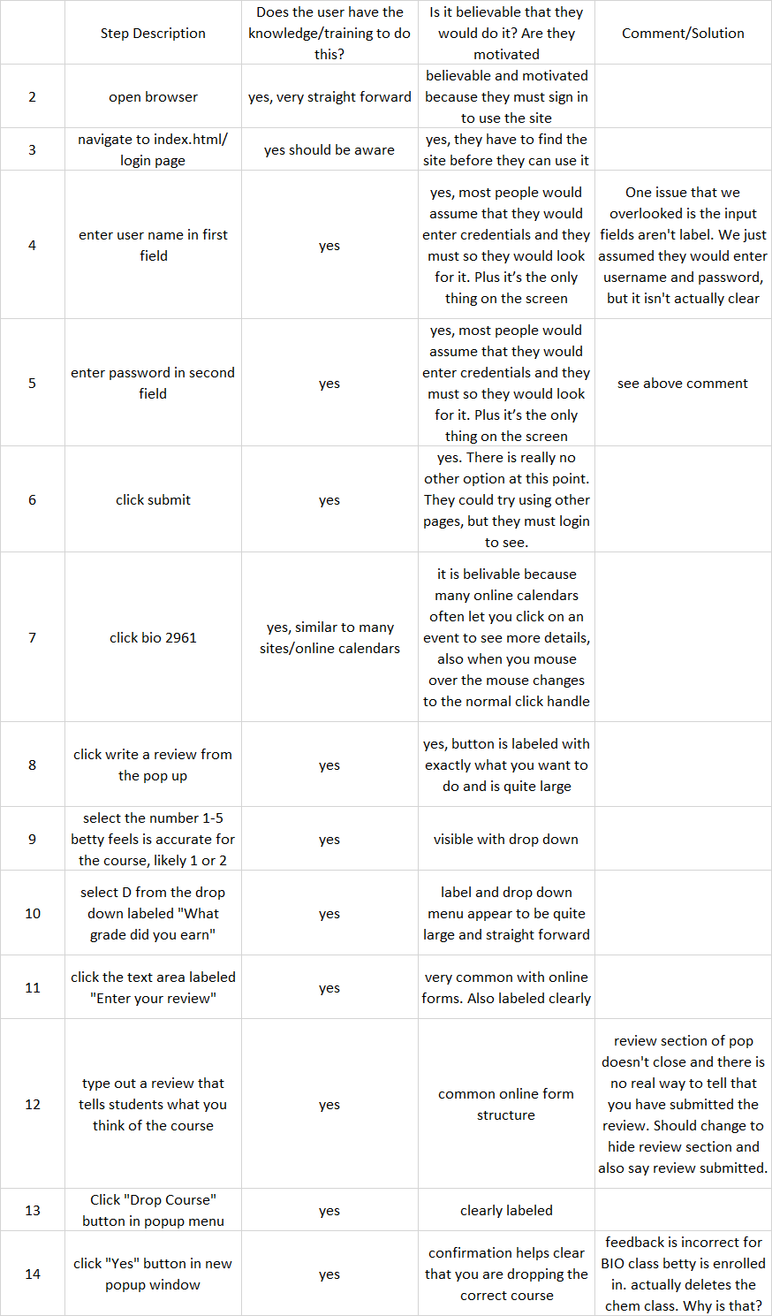

Problems from task one:

* username/password labels are missing
* Enrolled class deleted incorrectly
* Adding a review feedback is missing, no way to tell it submitted

2. You are the same user "betty" as before. You now need another class to enroll in after dropping BIO 2961, and you've heard your friends talk about a BIO 3041 class that they loved and you want to find more details about it to decide whether or not to register for it.

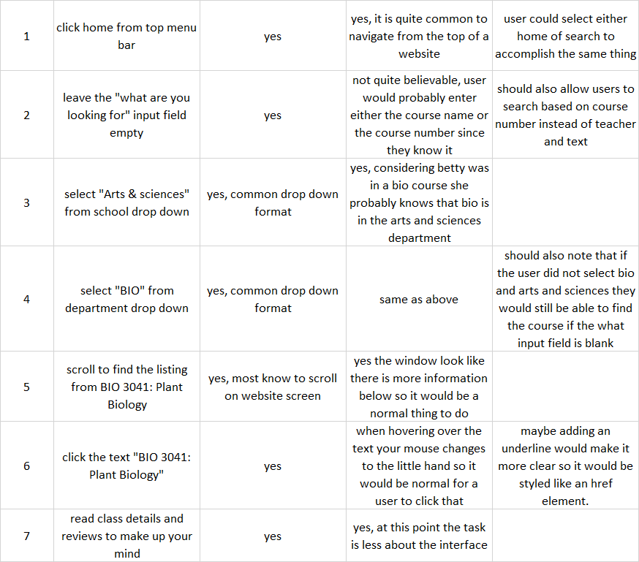

Problems for task two:

* Searching by course number isn’t functional

3. You are a Law student by the username "seth". You already have a registration worksheet ready and waiting that you have prepared, but you need to complete the registration process quickly to make sure you aren't waitlisted.

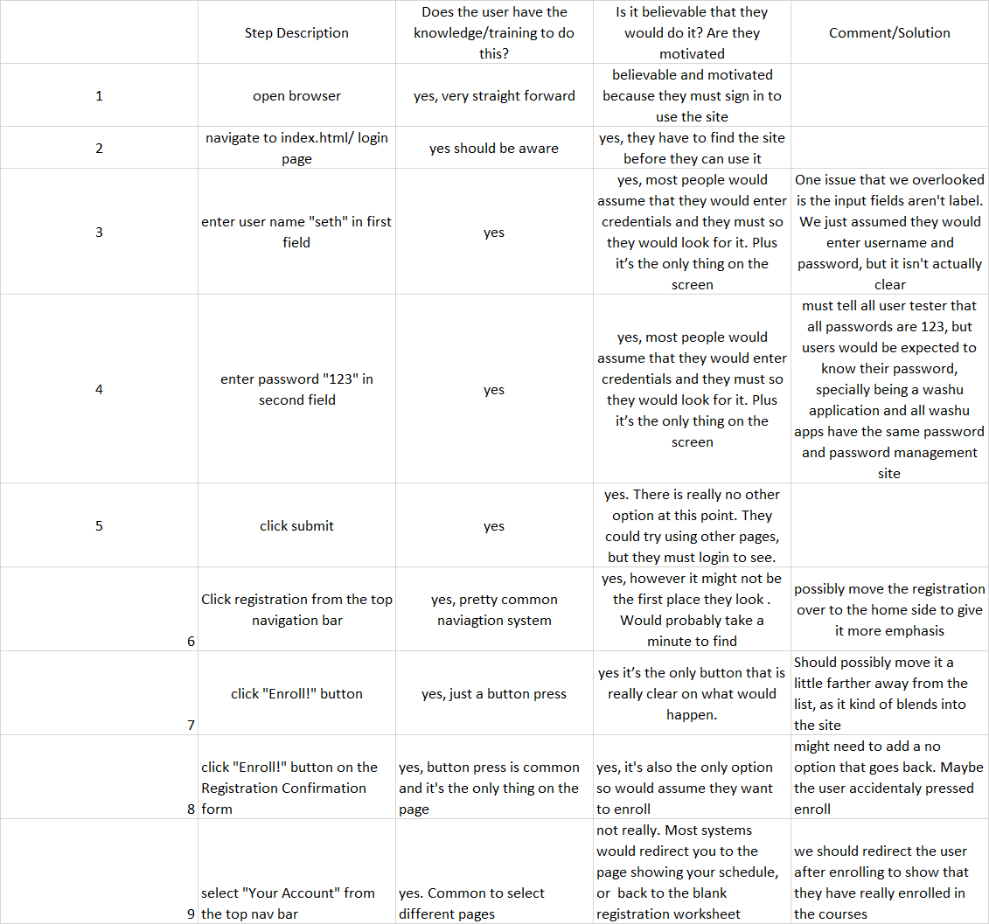

Problems from task 3:

* username /password not labeled
* Enroll button blends in with class list
* In registration confirmation form there is no no/back button
* Does not redirect after enrolling or show an empty wishlist.

4. You are a CS student named "dave". It is still registration period and you have signed up for a few courses, but feel like you need to take another. You need one more CS elective, and you need to find something that fits into your schedul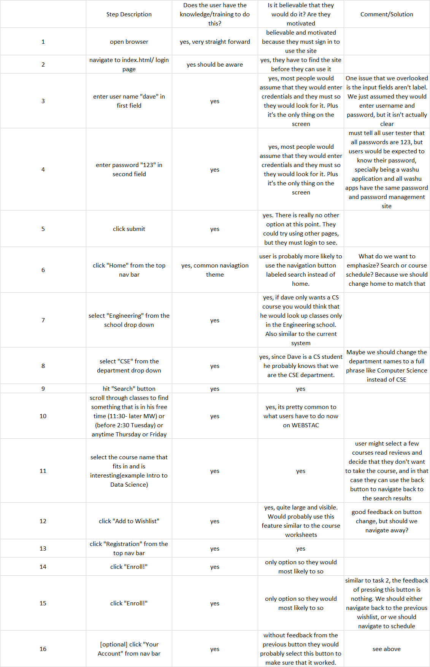

Problems for task 4:

* username/password not labeled
* Department names are only acronyms, not clear if not in the school
* After adding to wishlist we remain on the same page (should we navigate away)

5. You are a CS student named “sal”. You have completed most of your CS requirements, but not your A or S requirement. You want to find something you are interested in that will count towards your A requirements

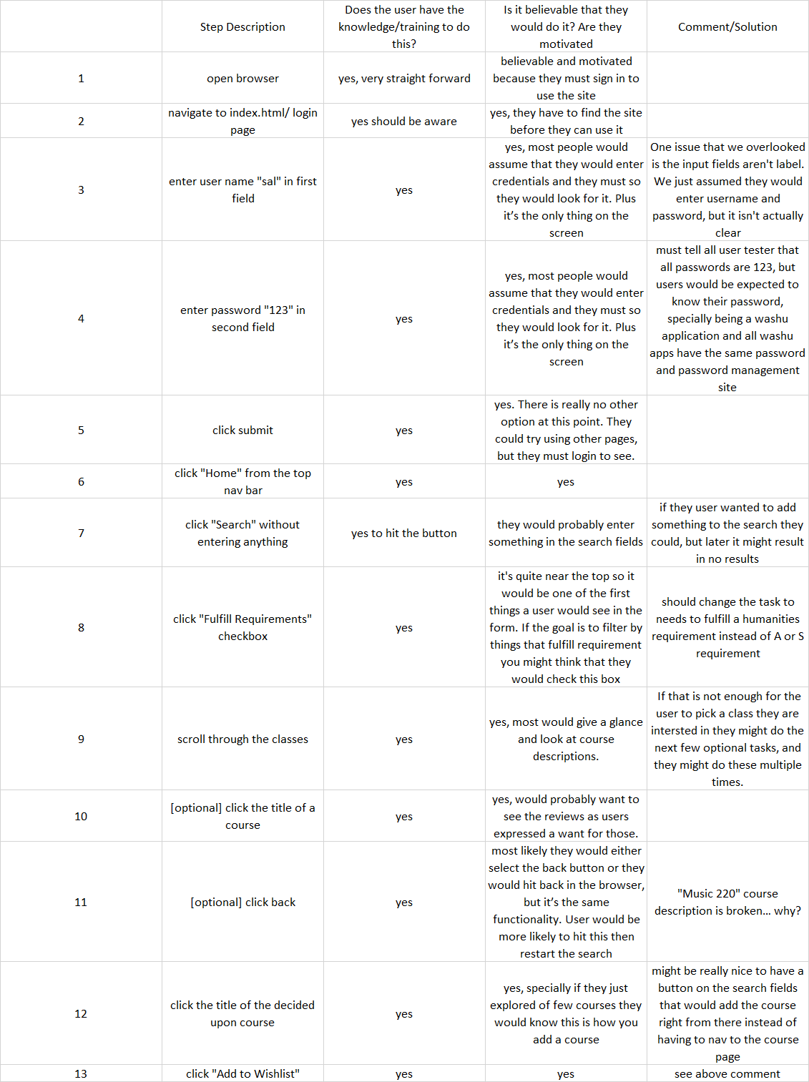

Problems for task 5:

* username/password not labeled
* Requirements in task description don’t match real requirements
* Music 220 course description doesn’t fill properly

6. You are a BIO student named “frank”. You started getting into music this past summer while at your internship. You have the space in your schedule and want to continue learning more about music this semester, and you have heard that jazz and K-Pop are really cool to study at WashU.

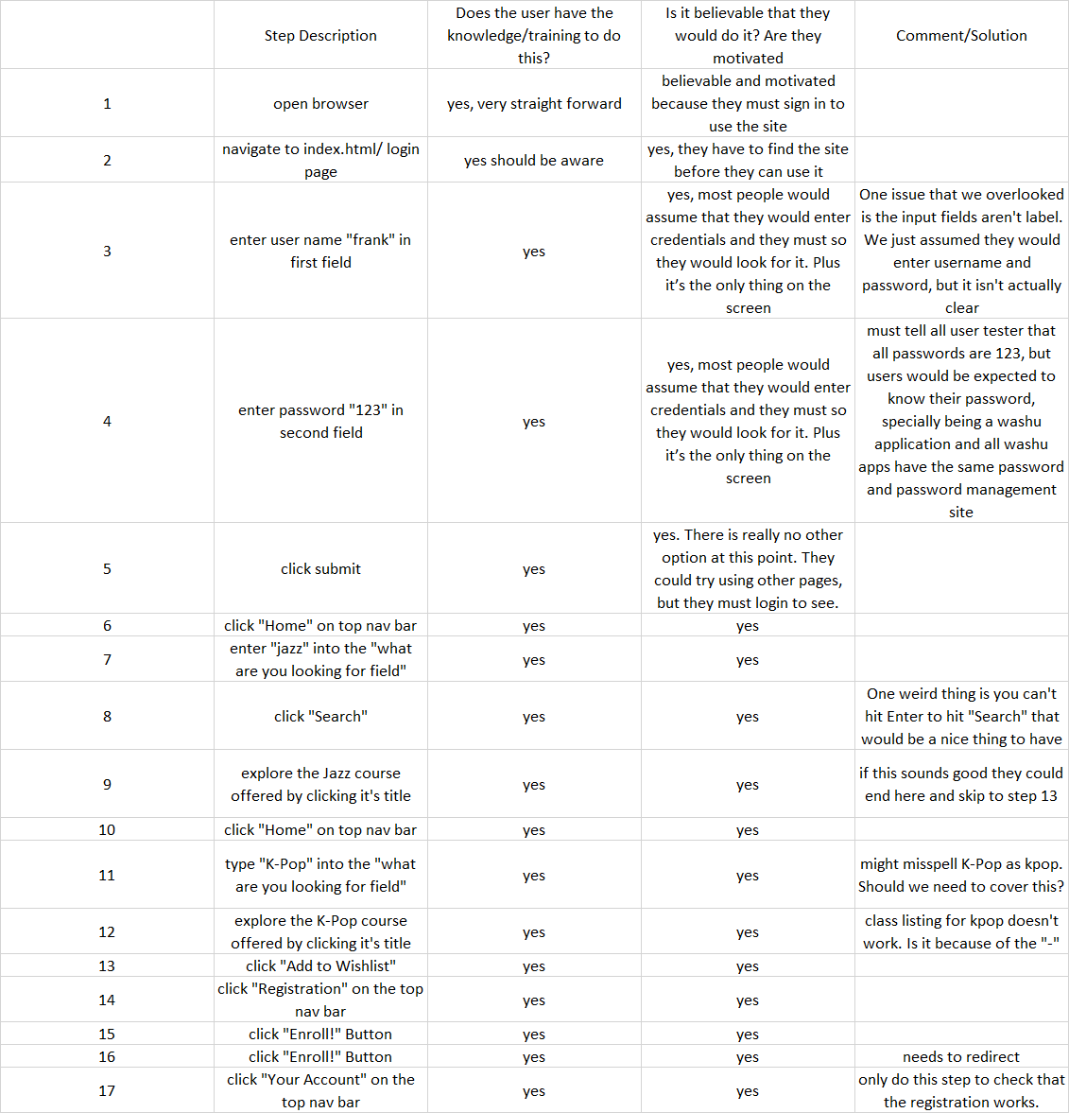

Problems in task 6:

* username/password labels missing
* Enter keypress doesn’t search
* K-pop class description is brokedn
* Enrolling confirmation issue again (should it redirect)

**Summary for Cognitive Walkthrough**

Our cognitive Walkthrough revealed a lot of interesting details about our digital prototype. One of the main issues that we had was a lack of feedback when completing forms. We either didn’t redirect, didn’t refresh, or simply didn’t confirm that that’s what the user actually wanted to do. For instance when a user enrolls there were taken to a blank screen with another enroll button. It wasn’t clear if they had already enrolled, needed to enroll still, or what happened, but if you navigated to the class schedule the student would be enrolled.

Another fairly simple thing that hadn’t really been caught in user testing was our input fields for username and password had no labels. We assumed that most people would enter username and password without really thinking about it and for all of our testing this had happened, but it wasn’t until doing the walkthrough that we noticed these labels were missing. This could cause a large issue with new students who were unsure of how to login.

An issue that also was noted was our enroll button was quite close to the list of classes and it was the same color. It wasn’t styled like an obvious button either. After changing the functionality to create a pop up confirmation we also wanted to make this button more apparent, and thus we changed the color, size, and location of this button.

We also noted a few issues with the way we displayed classes. When exploring the various classes in our 6th task it was noted that classes that contained single quotes or question marks weren’t displaying properly. We found that this was due to a parsing error, but it had just been something that no one had happened to explore before. On the same topic of functionality we also noted that our 5th task wasn’t correctly phrased. We had misinterpreted the requirements for this student and so our task wasn’t really doing what we were asking for. We updated our task to involve looking for a humanities requirement instead.

In task 2 we also noted that the correct way to search for a class when you only know class number, school and department is to search by leaving an empty field, putting in the department, and scrolling until you find it. While this is similar to the current webstac system it is a terrible way to complete the task. Because of this we added the functionality of being able to search by both course number in the form of either “BIO 3041” or “3041”.

Finally we also changed the display for departments in our search drop down. We had used the acronyms for the departments, but realized this might not be intuitive when you are looking for courses outside of your school. We added the full name to the list so as to make the department list more clear.

**Summary of things that were changed after the Cognitive Walkthrough**

1. Add user and password labels
2. Fix k-pop listingand Music 200
3. Needed to add sign out to class detail page
4. Change registration confirmation to a pop up window and on confirmation we reload the wishlist
5. Change task 5
   1. You are a CS student named “sal”. You have completed most of your CS requirements, but you still haven’t completed all your humanities requirements. You want to finish up your requirements soon and hope to knock the humanities requirement off this semester.
   2. Requires changing sal’s graduation requirements.
6. Change the look of the enroll button to make it stand out from the rest of your wishlist
7. Change department name to full names
8. Added ability to search by course number

We also noted a few things that we didn’t see as large problems but more as nice to have features. We decide that if they come up in user testing that we will address them then.

* Adding course to wishlist doesn’t redirect
* Home and search button do the same thing
* Adding an add to wishlist from search results
* Allowing key press “Enter” to submit forms

**Tasks for round three (after change in evaluation round)**

1. You are a Biology major at WashU with the username "betty". You are currently enrolled in BIO 2961 - Collaborative Phage Bioinformatics. You are currently getting a "D" in the course and are not enjoying it very much, so you wish to drop. Before you drop however, you want to write a review for the course to let future students know how you feel.

2. You are the same user "betty" as before. You now need another class to enroll in after dropping BIO 2961, and you've heard your friends talk about a BIO 3041 class that they loved and you want to find more details about it to decide whether or not to register for it.

3. You are a Law student by the username "seth". You already have a registration worksheet ready and waiting that you have prepared, but you need to complete the registration process quickly to make sure you aren't waitlisted.

4. You are a CS student named "dave". It is still registration period and you have signed up for a few courses, but feel like you need to take another. You need one more CS elective, and you need to find something that fits into your schedule..

5.You are a CS student named “sal”. You have completed most of your CS requirements, but you still haven’t completed all your humanities requirements. You want to finish up your requirements soon and hope to knock the humanities requirement off this semester.

6. You are a BIO student named “frank”. You started getting into music this past summer while at your internship. You have the space in your schedule and want to continue learning more about music this semester, and you have heard that jazz and K-Pop are really cool to study at WashU.

Round 3 interview Summary:

There are new issues discovered from the third round of user testing. A small number of problems are system side logical errors such as displaying incorrect confirmation message, incorrect dropping of classes due to server side query error, etc. These type of errors and issues are marked for fix with highest priority and some are already fixed. The major issues are with the intelligent borrowing since the users participated in the testing are experienced user and hence very familiar with current Webstac, from which they brings the user habits to the our newly prototyped system. Overall, the digital prototype we created has been demonstrated functional and is a complete system that allows the fundamental tasks to be accomplished without external guidance.

The system can be further improved or refined by conducting more user testing and fixing the issues discovered through the testing. Therefore, for future steps, more user testing is encouraged.

**Changes after Round 3 Interviews:**

* Visual glitch when dropping course, sometimes the wrong course vanished until refresh
* After leaving a review, if you try to leave a review for another course the popup form is still filled
* Shouldn’t be allowed to leave reviews on the search option (at least for courses you haven’t taken)
* When confirming registration wishlist, the wrong message is in the popup
* Shows if your course schedules are going to overlap when in registration worksheet.
* Want to see all departments when selecting from “All Schools”
* The department/school for music courses in task 6 aren’t listed in the drop down

**Round 3 Interview 1 Transcript:**

Austin: Are you ready to begin?  
Taylor: I am

A: You are a student at WashU with the username ‘betty’ you are currently enrolled in BIO 2961 - Collaborative Phage Bioinformatics. You are currently getting a D and not enjoying it very much so you wish to drop. Before you drop however, you want to write a review to let future students know how you feel.

T: Okay.

A: Your password is “123” by the way.

T: So I don’t have to sign up, I just use my own username and password?

A: No, your username is betty for this task

T: Oh duh. Cool, cool. I see a bio course here, Phase Informatics. I’m going to click on it, now “write a review”. Alright there is a 1-5 scale. I don’t know if 5 is the best or 1, but I’m going to assume 5. Man, I hated this course, so I’m going to rank it a 1. Uhhh I was getting a D. I’m going to write a review here. Click submit. “Are you sure?” Not really, but I’ll hit okay anyway. Alright, my bio course is gone, and my chem courses are still here. I wish that I could just click “drop course” and the option to write a review would automatically come up.

A: Oh okay

T: I’m going to snoop through the other tabs. There’s an academic calendar, it’s even got Fall Break on there, I like this. I can see here are the reviews that I’ve made. I don’t really like the layout of this. The score seems strange in the middle, it might look better on the far left, and make my text a bit bigger and more prominent. I either didn’t understand the 1-5 scale, or there’s no color gradient for the values. It seems weird that a score of “1” is green.

A: Right, right.

T: Can I leave another review? I can. Oh my form from before is still there. That’s okay, we’ll move on haha. Oh, in my reviews there are circles and a number showing my score. I’m not really sure that’s needed, I think the number alone is probably enough. Let’s see what else I can play around with.

A: Well, we have more tasks for you to do.

T: Oh, let’s do those then.

A: You are the same user "betty" as before. You now need another class to enroll in after dropping BIO 2961, and you've heard your friends talk about a BIO 3041 class that they loved and you want to find more details about it to decide whether or not to register for it.

T: Okay, I’ll click search, oh I like the background here. Okay, I’ll search for “3041” and I’ll select school… I guess it’s ArtSci, and Bio. There’s some courses, let’s see.. There’s 3041. Gives some nice detail about Plant Biology. If I click on it I can see some more information, including a review, alright. This seems a bit weird, the review says that the class has a lot of homework, but it has a rating of 4… Maybe 1 is the highest? I assume the 4.0 at the top is the average review score. In any case, I’ll add the course to my wishlist. Where is my wishlist? Not in my calendar, or my current schedule.. Is it registration? Okay there it is. That seems like a weird phrasing to me, perhaps just call it “wishlist”. I’ll click enroll. Why is it asking me to drop? That seems wrong.

A: Oh, that’s a typo there.

T: Oh okay. I’ll click yes then. Oh, it registers all the classes at once, that’s better than WebSTAC. And I can see 3041 has been added. It seems weird that there’s still an enroll button even tho I have no courses on the worksheet.

A: Okay. Anything else?  
T: I think that’s it for now.

A: Okay. Task 3: You are a Law student by the username "seth". You already have a registration worksheet ready and waiting that you have prepared, but you need to complete the registration process quickly to make sure you aren't waitlisted.

T: Okay, I’ll log out, and log in as ‘seth’. I’ve got nothing in my schedule, but I need to register quick. I’ll go into my worksheet and register all these bad boys at once. Now if I go to my account… nice, just a one click thing, that’s awesome. I love that.

A: Great! That’s it for that one. Task 4 is: You are a CS student named "dave". It is still registration period and you have signed up for a few courses, but feel like you need to take another. You need one more CS elective, and you need to find something that fits into your schedule.

T: Alright, I’ll log in as them… I can see that I’m taking 247 and 332. Let’s look at graduation requirements. Looks like I need 347 and a few other things, alright. Let’s go to search for courses, and I’ll search for all Comp Sci courses… Aren’t they ArtSci?

A: No, they’re the engineering school

T: Oh that’s right. Okay CS. Let’s see. I enjoyed Cosgrove as a dude, I’ll take 247. Add it to my wishlist. Seems like a tough class, but that’s fine. I’ll sign up for one more. Having the back button is a little awkward.

A: Having it at all?  
T: No, just having it in the nav bar. I think it would be better next to the title, that seems more natural.

A: Is the word “back” clear or would you prefer an arrow?   
T: I would prefer both I think. Back is pretty clear on its own though. I’ll also take 332 as well. Seems cool. Let’s.. not drop it. I thought I was taking 330?  
A: I think you were in 332.

T: Oh okay, I’ll sign up for 330 then. Go to my worksheet and finish the deal. Oh, looks like my courses overlap. I wish it would’ve told me when I was registering. In that case I’ll drop 330 and then refresh the page.

A: Okay, next task. You are a CS student named “sal”. You have completed most of your CS requirements, but you still haven’t completed all your humanities requirements. You want to finish up your requirements soon and hope to knock the humanities requirement off this semester.

T: Okay humanities. I don’t really know what to take. I guess I’ll just search all schools. Oh, it would be nice to see all the departments here. There does seem to be lots of departments missing… Hmm.

A: Say you want to take a Chem course then

T: Okay. Chemistry then. I guess I’ll take general chemistry. I’ve heard good things about it, and it beats OChem. So I’ll sign up for that.

A: Perfect. Last one then: You are a BIO student named “frank”. You started getting into music this past summer while at your internship. You have the space in your schedule and want to continue learning more about music this semester, and you have heard that jazz and K-Pop are really cool to study at WashU.

T: Okay, I’ll search for the music courses… What department are they under?

A: I don’t think they were added in correctly to be honest.

T: That’s fine, I’ll go to all courses and just search the page. There they are. Add that to my wishlist. A bit of unnecessary work, but I found it. Let’s search now for K-pop, there it is.

A: Perfect. Do you have any other concerns other than what we’ve discussed.

T: There’s a few things I noticed. Sometimes the nav bar goes invisible, and that’s nice, especially for the search page with its background picture, but it can be unclear what its purpose is when that happens. Is it possible to filter your search?  
A: Yes, on the search results page you can filter by grad/undergrad courses and weekday.

T: Oh okay. Is it dynamic? Yes it is, okay that’s nice to have I like that. I like how all the information is here, I don’t have to click into each course’s individual page to get more information about it. Maybe left align the title of the course as well, I prefer that personally. For the search results, maybe show that it’s 4.0/5 or whatever so I can tell what the highest score is at a glance. My one other comment is that it would be nice to only register for some of the classes in the worksheet. Maybe mark them with a checkmark, then when you click enroll, only enroll in the checked courses.

A: Nice, nice. Anything else?  
T: Nope, I think that’s about it.

A: Alright, thank you for your time.

Sojin, Master, Electrical Engineering

Hi Sojin, thank you so much for doing the testing for my course project Wesbstac redesign. The testing consists of six tasks that you need to complete. They are short and just need to be done in our prototype to test our system usability.

S: Okay

So the first task is to writing a review and drop the course. Let me show you and also read the full task description to you.

Suppose you are a Biology major at WashU with the username "betty" and password 123. You are currently enrolled in BIO 2961 - Collaborative Phage Bioinformatics. You are getting a "D" in the course and are not enjoying it very much, so you wish to drop it. Before you drop the course, however, you want to write a review for the course to let future students know how you feel.

Is that clear to you?

S: Yes.

Good. Let’s start it! Please explain your thoughts whenever you are making a decision or doing some kind of actions that is not self-explanatory.

S: No problem.

(Show the index page to Sojin)

S: First, log in as “betty” with password “123”

(Clicks on username and type in betty)

(Presses tab key and type in 123)

(Presses enter key)

(Presses enter key again)

(Clicks on submit)

S: That is kind lame. And slow. Switching back and forth between the keyboard and mouse is annoying so I want to be again to log in by hitting enter.

Okay. I will write that down.

S: Now course to write the review and to drop. BIO 2961.

(Scrolls down the page and clicks on BIO 2961)

S: Write a review

(clicks on write a review)

(Panel showing up for writing review)

(Scrolls down)

S: I don’t think I can write the review. There is a problem scrolling down.

S: So you see, this area is showing partly and stays still even I scrolled down.

Yeah, I think that is a problem. I didn’t encounter it until now. Maybe it’s because the screen resolution is small that the panel wouldn’t show up.

S: Yeah. Most likely.

I’ll have it fix later but now let me zoom the display page so you can continue the testing.

S: Okay.

*** Fix the problem when the screen resolution is small ***

(Zoom out the page so the whole panel is showing)

Please continue to finish the first task.

S: Okay. I’m gonna write a bad review for this class

(Selects drop down for numbers 1)

S: Low rating

(Selects drop down for grade)

S: Getting D

(Types in review)

S: And not fun.

S: Submit!

(Clicks on submit)

S: So the panel is closed. That part is complete. Now drop the class

(Clicks on BIO 2901)

S: Drop the course

(Clicks on drop the course)

(Clicks on yes)

S: I think I encountered another problem.

Hm?

S: So after I dropped the BIO 2901, it is still on my calendar but another course I don’t remember, just disappeared.

Yeah I think one CHEM class is now gone. I think the script is acting weird now. I’ll write that down but let’s pretend you dropped BIO 2901 and finished that task.

*** BIO 2901 not dropped but CHEM ***

S: Alright.

One second I will get the second task. The second task would be searching for a course in our system. Let me read the full description to you.

Continue as Betty. You now need another class to enroll in after dropping BIO 2961, and you've heard your friends talk about a BIO 3041 class that they loved and you want to find more details about it to decide whether or not to register for it.

S: Okay.

You can start now.

S: Okay.

(Clicks on search on top of the menu)

Can you continue to explain your actions?

S: Sure. So to find more details about the course, I’m first thinking of search it by keyword and I assume search is for searching courses.

Okay.

S: So BIO 3041

(Types in bio 3041 in the what are you looking for)

(Hit enter and after a second clicks on submit)

S: Okay. Find more about BIO 3041

(Scrolls down the result page)

(Scrolls to the 3—range? But didn’t find it so he scrolled down a bit more)

(Hit ctrl + F and searched for 3041)

(Clicks on BIO 3041)

(Scrolls down and up to explore the course description page)

S: I think that is the details I can find about this course.

Good. I think you have completed this task.

S: Okay.

So let me give you another task. It’s about registration but this time you are not betty.

Now assume you are a Law student by the username "seth" and the password is still 123. You already have a registration worksheet ready and waiting that you have prepared, but you need to complete the registration process quickly to make sure you aren't waitlisted.

S: okay

(Shows the index page again to Sojin)

S: log in as seth and 1 2 3

(Clicks on username and types in seth)

(Presses tab and types in 123)

(Clicks on submit)

S: Logged in. Now go to registration for the courses

(Clicks on registration on the top right menu)

S: So here is the list Seth wants to sign up for.

(Scrolls down the page to see the list)

S: Enroll

(Clicks on enroll)

(Clicks on yes on confirmation pop up)

Did you read what’s on the pop up?

S: Not the whole thing. I believe it ask if I’m sure to enroll or something.

Okay.

S: So yeah, I think I finished signing up for the courses.

Good. Let’s continue with another simple task.

S: Okay

So the next task is to find courses that will count toward your degree.

Assume you are a computer science student named “sal”, and the password is still 123 for testing convenience. You have completed most of your computer science requirements, but not your humanities requirement. You want to find something you are interested in that will count towards your requirements so you can wish list it.

Is that description clear?

S: I think so.

(Back to the index page for Sojin to text)

You can start now.

S: first log in as sal

(Clicks on username and types in sal)

(Presses tab and types in 123)

(Clicks on submit and log in)

(Clicks on graduation requirements tab)

(Scrolls down to see the details)

(Highlights unfulfilled requirements)

(Clicks on search)

Sorry to interrupt, but can you explain each time you click on something.

S: yeah sorry.

S: so I noticed the graduation requirements tab using the website, and it is natural just to check the details in the page. And also going to search page to find the courses.

Okay.

S: So art course is in sam fox school so

(Select design and visual art from the school drop down)

(Checks the department drop down but there is no options)

(Clicks on search)

S: so no results in visual art school. Let me try another

(Hits backward to search page)

(Selects arts and sci)

(Checks the department but no options for art)

(Unselects department)

(Unselects school)

(Clicks on search)

S: so I don’t see any search on Art department I’m gonna check all course listings.

(Clicks on fulfill requirements)

S: so this option filter out other courses. This is cool

S: art classes that counts towards requirements

S: can I just do the first one?

Yes.

(Selects ARCH 101 drawing)

S: add it to wish list

(Clicks on add to wish list)

S: I’m done.

Good! Thanks so much. Just one last task. It will be very quick as well.

S: Sure.

So the last task is to search for courses.

You are a BIO student named “frank” with same password. You started getting into music this past summer while at your internship. You have the space in your schedule and want to continue learning more about music this semester, and you have heard that jazz and K-Pop are really cool to study at WashU.

S: Sure.

(Log out of the page and the index page for Sojin to test)

S: so same routine, log in as frank

(Clicks user name and types in frank)

(Presses tab and types in 123)

(Clicks on submit)

S: same search

(Clicks on search on the top right menu)

S: so jazz

(Types in jazz)

(Clicks on search)

S: one class found for jazz.

(Clicks on AMCS 105)

S: and let me wish list it

(Clicks on add to wish list)

S: now for k pop

(Clicks on back on top left menu)

(Clicks on back on top left menu)

(Types in K-pop and hits search)

S: also one course found, Korean 355 Korean Performance blah blah

(Clicks on the course)

(Clicks on add to wish list)

S: I think I’m done with task.

Thank you so much! Let me verify they are indeed added. Can you check if the two classes showing up in the registration?

S: yeah. They are here

Good. Thank you so much for doing the testing!

S: you are welcome.

Ted, Junior, Biology

Hi Ted, thank you for being my volunteer tester for my course project, which is redesigning the Webstac registration portal.

T: No problem. What are you testing on?

We are mostly testing the feasibility and usability of our digital prototype. So I will give you some tasks to complete in our prototype and record any problems you encounter. I would really appreciate it if you could explain every action that you make so I can better understand your process and what is causing the problems.

T: I will try my best.

Thank you so much. So first task would be, assume you are a Biology major at WashU with the username "betty" and the password is "123". You are currently enrolled in one class and the full title is BIO 2961 - Collaborative Phage Bioinformatics. You are currently getting a "D" in the course and are not enjoying it very much, so you wish to drop. Before you drop however, you want to write a review for the course to let future students know how you feel. Is the task clear to you?

T: Yes.

Then you are good to start.

T: So this is the index page

(Clicks on the index page)

T: logging in as this Betty person

(Clicks on the username field to type username and then same with pass word field)

T: log in

(Hit the enter key on the keyboard but the system is unresponsive, no action for the input)

T: (confused for a second but quickly uses mouse to click on submit)

T: Why must I click on submit to log in?! I think everybody will complaint about it so maybe you should think about making enter work as clicking on submit

Your suggestion will be recorded.

T: Now I have a class schedule in front of me.

(Scrolls down and up to see what’s on the page)

T: It’s the only content on the page and it seems empty.

T: So I should be writing a course review for which class?

BIO 2961 Collaborative Phage Bioinformatics.

T: Okay. BIO 2961

(Clicks on BIO 2961 on the schedule)

T: (checked the course title and time on the pop up panel before clicks on the write a review button)

T: I should be giving low rating, low grade, and bad review as Betty. So selecting 1

(Selects 1 from the drop down)

So what do you think that drop down number is?

T: Rating? It seems so.

T: Alright. Bad grade

(Selects D from the second drop down) and bad review.

T: This course is boring and there are too many exams

(Types in).

T: Is that review okay?

Yes. You can write whatever you want.

T: Yeah submit.

(Clicks on submit)

T: That’s it? Do I get any confirmation of successfully submitting the review?

Yes. I will write it down that you are expecting a confirmation message such as a pop up dialogue.

T: Yeah. Pop up might be annoying but I’m not used to nothing. It feels like the system is just listening but not making the answer.

Got you.

(The course detail panel closed)

T: (Clicks on the course again)

T: I also think that after the confirmation pop up the panel thing should still be there. So I can drop the course conveniently. I’m not sure if that’s correct, maybe just the task you give me favors that.

Don’t worry I think you have a good point. I will write that down as well.

T: Drop the class

(Clicks on drop the class)

T: And yes

(Clicks on yes on the confirmation pop up)

T: Okay the class is gone.

Okay good I think you are a pretty good tester.

T: No problem.

So the following task. Suppose that you, Betty, have heard your friends talk about a BIO 3041 class that they loved and you want to find more details about it to decide whether or not to register for it.

Continue from the last task.

T: Alright. Find more detail about BIO 3041

(Clicks on search on the top right menu)

(Page directed to search page)

T: 3041 in biology

(types in BIO 3041 in what are you looking for search field and clicks on submit)

T: okay biology 3041

(Clicks on BIO 3041)

T: (Reading the course description …)

T: I think I like it, what to do next?Could add it to my wish list.

T: Okay.

Sean, Psychology, Senior

Hi Sean, thank you for participating in my course project testing, I would really appreciate your time and input.

S: I’m happy to help you.

Thank you so much! So my project is about redesigning the Webstac. Right now we have a digital prototype and want you to work on two tasks on the system so that we can test certain usability of the system.

S: Okay sure.

So the first task is pretty simple. Assume you are a law student whose username is “seth” and the password is “123”. Your registration worksheet is already planned, and now you want to complete the registration process. You can think of it as seven thirty in the morning when the registration is just open. Is that clear?

S: Yes. So I’m supposed to log in with the credential and register my wish listed courses.

Yes, that’s correct. Before you start, I would like you to speak out your process whenever you are making a decision or some kind of action that is not self-explanatory.

S: Okay. Will do.

Let’s start it at the log in page.

S: I think the black text is not a good match for the background

(Highlighting the username and password)

You mean Username and Password?

S: Yes.

Okay. I will put that note down.

S: (Types in the credentials and hit enter)

S: (Clicks on submit)

(Directs to the home page)

S: registration registration registration … repeats

(Clicks on registration on the top right menu)

S: registration confirmation? Is that supposed to be my wish list?

Yes. They are. Would changing registration confirmation to wish listed courses be more clearer to you?

S: absolutely.

S: now I’m just enrolling? As the registration just opens?

(Clicks on enroll)

(Pop up message)

S: are you sure you want to drop these courses? Wait what?

I think there is a mistake in the pop up message, it should be saying “are you sure you want to add there courses”. I’ll mark it for fix. Thank you for noticing it.

*** fix the enroll pop message ***

S: no problem. So do I continue to enroll?

Yes.

(Clicks on yes)

S: The courses (list) disappeared. Can I assume they are added?

Yes. So would you think a confirmation message like “you are added to the courses” be helpful?

S: definitely. Right now I just know the system will respond but don’t know what kind of respond they actually make.

Alright. Thank you for your feedback. I think you have just completed this task for registration. Ready for another task?

S: sure.

So now you are a computer science student and you can log in with dave and 123. It is still registration period and you, dave, have signed up for a few courses, but feel like you need to take another. You need one more CS elective, and you need to find something that fits into your schedule.

S: alright. Find computer science electives that I can take and fit my schedule. I think that would be pretty hard depending on the schedule. What is my current schedule?

You can find the information in your account in the system. I should have let you just explored the system but I feel bad if I don’t answer your question.

S: I’ll try next time before I ask

S: so first my schedule is part of my account information, so my account

(Clicks your account on the top right menu)

S: here you go. My schedule, ah, I don’t think the date, without which day in the week, is a good idea for schedule listing.

I agree. I’ll write that down.

(Scrolls the calendar)

S: so I assume Monday and Wednesday morning ten to eleven thirty is for CSE 332 and Tuesday afternoon two thirty to four is for CSE 247.

Yes. You are right.

S: let me search for the computer science electives.

(Clicks on the search on the top right menu)

S: computer science is in engineering school so

(Choose engineering school from the drop down menu and select department of computer science and engineering, clicks on submit)

S: search

S: so that’s the result. How do I find that I have met the prerequisite for certain classes?

Maybe check the course description.

S: ok

(Clicks on CSE 131, read description)

S: no prerequisite for CSE 131

(Hit backward. Clicks on CSE 132, read description)

S: didn’t say anything about prerequisite either

(Hit backward. Clicks on CSE 204, read description)

S: no? I guess there is no way to check prerequisite?

(reads the course time and scroll around)

S: so I think except CSE 330, all other courses are non-overlapping. Do I just randomly chose one.

Originally the result will be further narrowed down but now that the prerequisite doesn’t work I would say that task would end here. So thank you so much!

S: no problem.

*** maybe implement system check for prerequisite and time (like the fulfill requirements option in the search top) ***